

**DIVIDING current and voltage**

***Team 8***



Members:

* Soriano Montiel Bryan Andrés
* Montaño Ayala Alan Israel
* Vargas Romero Erick Efraín

Teacher: Durán Camarillo Edmundo René

Learning unit: Fundamental analysis circuit

Practice: 05

Sequence: 1CM14

Semester: 2016 – 2017 “A”

Index

1. Voltage divider 3

2. Current divider 6

3. Simulations 8

3.1 Voltage divider 8

3.2 Current divider 9

4. Questionnaire 11

5. Conclusions 12

5.1 Soriano Montiel Bryan Andrés 12

5.2 Montaño Ayala Alan Israel 12

5.3 Vargas Romero Erick Efraín 13

6. bibliographies 14

# **1. Voltage divider**

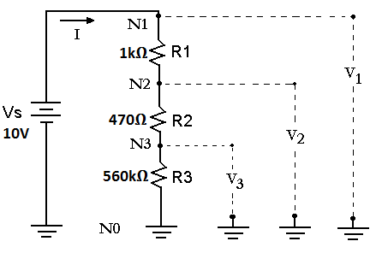In the first part of this practice, a circuit (Figure 1.1) once built the circuit, we proceeded to adjust the voltage source to ten volts, and the current source, was set to maximum, once the above fact was built, perform the corresponding measured using the voltage divider, this for R1, R2, R3 and calculating the V1, V2 and V3 voltages in table 1.1 resistances can see the results obtained in the calculation analytically, and obtained by the measurement circuit

Figure 1.1

|  |  |  |  |
| --- | --- | --- | --- |
| *Fact* | *Theoric value* | *Measured value* | *Error ΔV ó ΔI* |
| VR1 | 4.92V | 4.95V | 0.03V |
| VR2 | 2.31V | 2.32V | 0.01V |
| VR3 | 2.75V | 2.75V | 0 |
| V1 | 10V | 10V | 0 |
| V2 | 5.07V | 5.08V | 0.01V |
| V3 | 2.75V | 2.75V | 0 |
| I Total | 4.75mA | 4.76mA | 0.01mA |

Table 1.1

Below we have an example calculating the voltage in R1

$$VR1=Vs\left(\frac{R1}{R1+R2+R3}\right) VR1=10ν\left(\frac{1000Ω}{1000Ω+470Ω+560Ω}\right) VR1=10ν(\frac{1000Ω}{2030Ω})$$

$$VR1=\left(\frac{10000}{2030}\right) VR1=4.92 v$$

Where the error is calculated using Eq. 1.1 and the voltage of each resistor is calculated with Eq. 1.2 eq. 1.2 is simple to understand, the voltage resistance is obtained by multiplying the source voltage Vs by the resistance resulting from which we want to know the voltage between the sum of the resistances that are in series with it



Eq. 1.2

Eq. 1.1

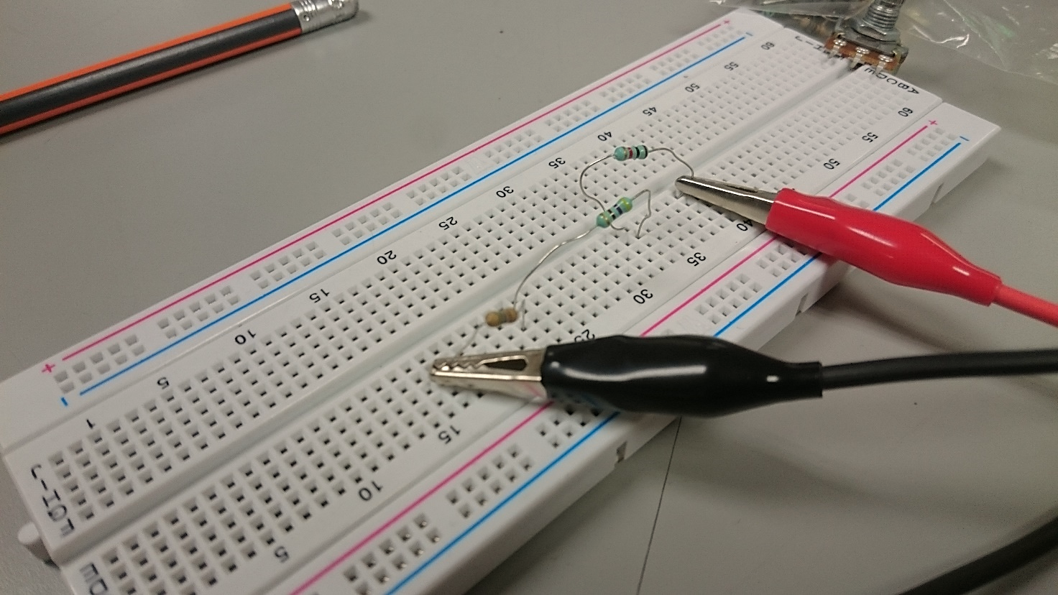

Image 1.1

We can see physical circuit

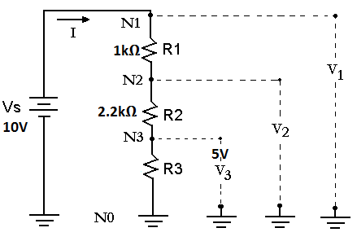

calculating a resistance was also performed, this based on the diagram in Figure 1.2, assuming R1 = 1kΩ and R2 = 2.2kΩ this calculation was made taking into account that a voltage is wanted in V3 5V and if Vs = 10V

Performing the calculations, we get the value of a resistor of 3.2 KΩ

Figure 1.2

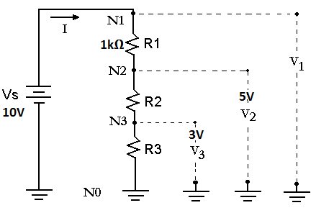

Finally, a circuit was constructed as shown in Figure 1.3 with Vs = 10V for which we had to calculate the value that had resistance to this proposition of a R1 = 1kΩ resistor was made the final result is shown in the table 1.2

|  |  |  |  |
| --- | --- | --- | --- |
| *Fact* | *R1* | *R2* | *R3* |
| *V2 = 5V* | *1* kΩ | *560* Ω | *440* Ω |
| *V3 = 3V* | *1* kΩ | *560* Ω | *642.85* Ω |

Figure 1.3

Table 1.2

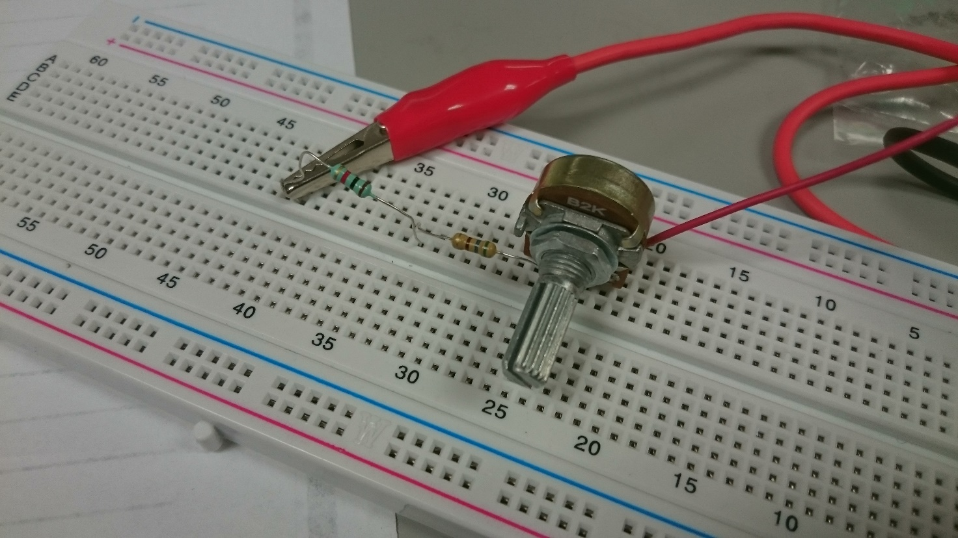

Image 1.2

In this image we can see physical circuit.

# **2. Current divider**

The current divider is similar to the voltage divider, but as we recall some theory, the voltage divider must have elements in series, however, the flow divider must have parallel elements

For this part of the practice, we adjust the voltage source to ten volts, and the current source to the maximum, then hopped on the tablet the circuit shown in Figure 2.1, finally, we made measurements of current, resistors R1, R2, R3, R4 using current IR1 results are shown in table 2.1

Figure 2.1

|  |  |  |  |
| --- | --- | --- | --- |
| *Fact* | *Valor teórico* | *Valor medido* | *Error ΔI* |
| I R1 | 6.37mA | 6.46mA | 0.04mA |
| I R2 | 3.62mA | 3.47mA | 0.15mA |
| I R3 | 1.64mA | 1.61mA | 0.03mA |
| I R4 | 1.09mA | 1.07mA | 0.02mA |
| I Total | 6.37mA | 6.46mA | 0.09mA |

Table 2.1

Below we have an example calculating current in R1

$$IR1=\frac{R2+R3+R4}{R1+(R3//R3//R4)} IR1=\frac{1000Ω+2200Ω+3300Ω}{1000Ω+(1000Ω//2200Ω//+3300Ω//)}$$

$$IR1=\frac{6500Ω}{1000Ω+0.132} IR1=\frac{6500Ω}{1000.132Ω} IR1=6.37μα$$

Where the error ΔI is calculated with Eq. 2.1



Ec 2.1

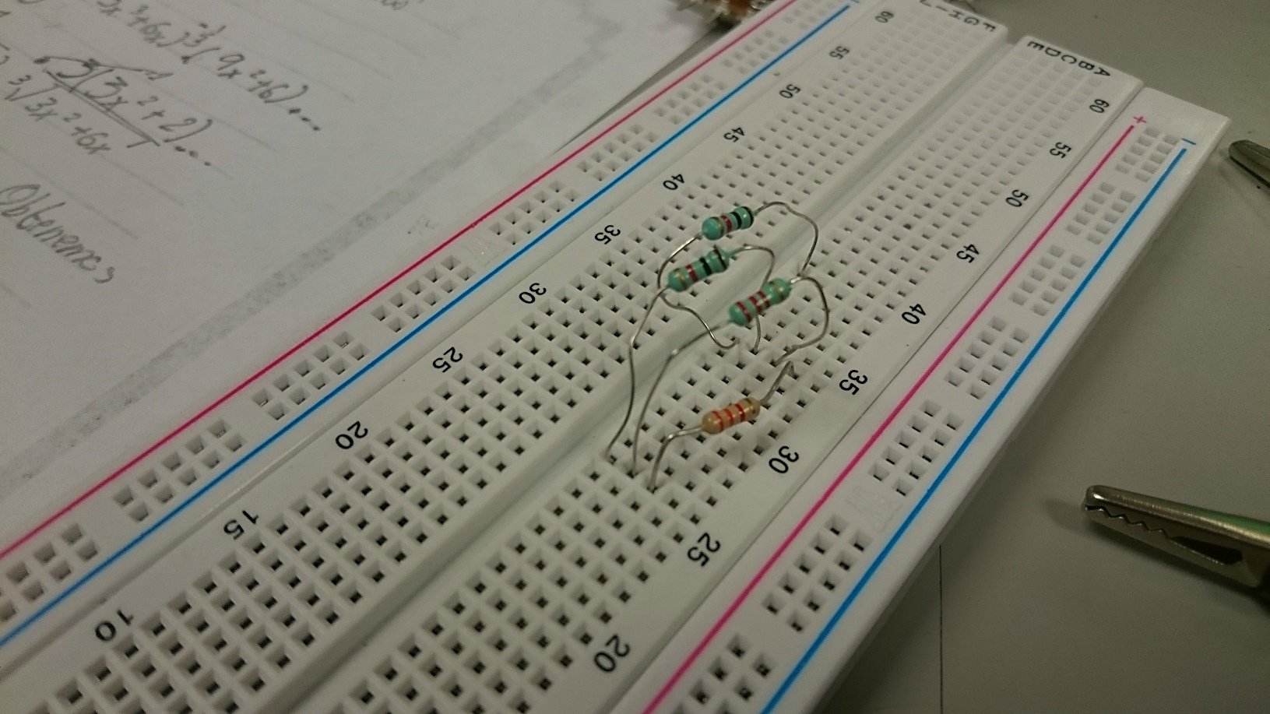

Image 2.1

In this image we can see the physical circuit

# **3. Simulations**

## **3.1 Voltage divider**

Simulation 3.1.1

We can see the voltage that flowing in each node

## 

Simulation 3.1.2

We can see the voltaje flowing in each resistance

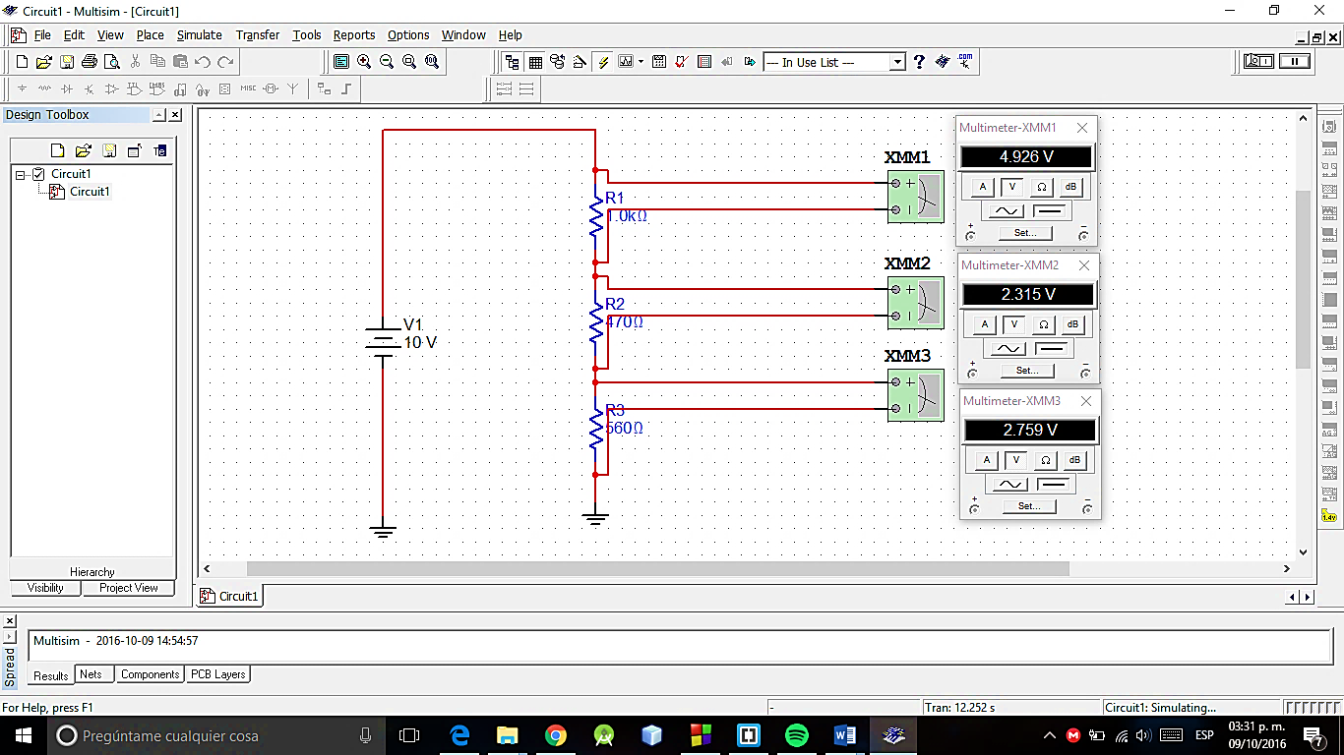

## **3.2 Current divider**

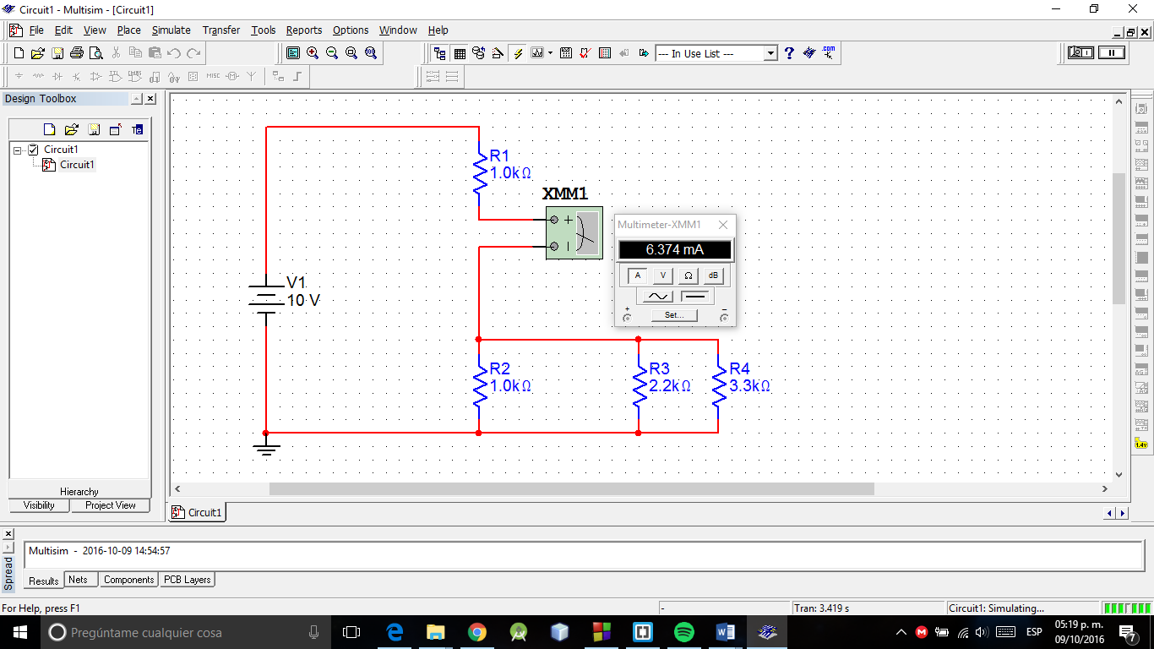

Simulation 3.2.1

In this image we can see the current in R1

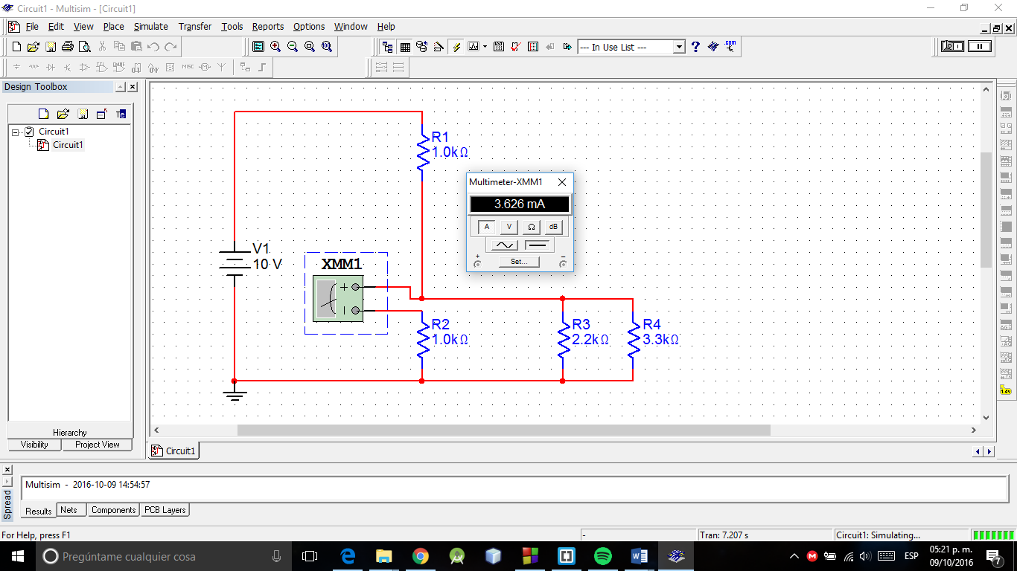

Simulation 3.2.2

In this image we can see the current in R2

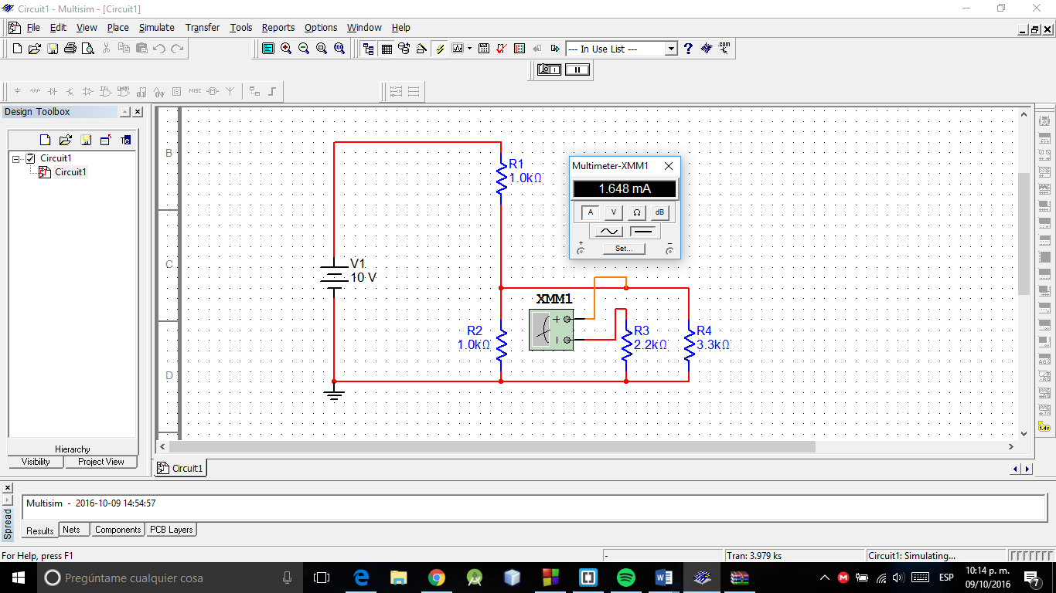

Simulation 3.2.3

In this image we can see the current in R3

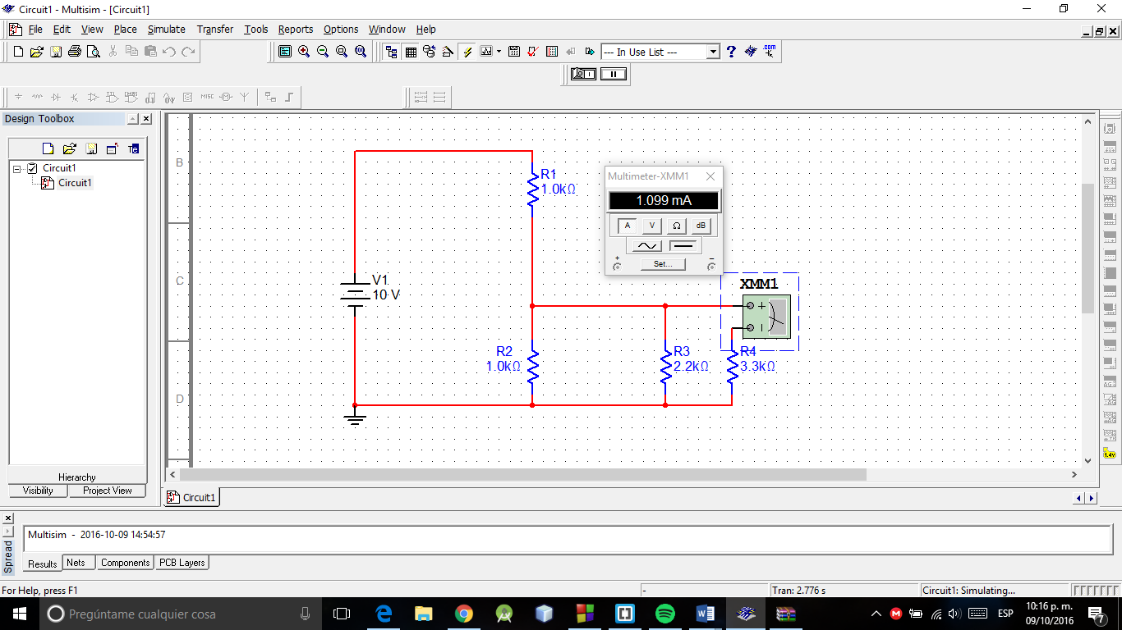

Simulation 3.2.4

In this image we can see the current in R4

# **4. Questionnaire**

1. **What the existence of error or deviation of the measured value should be compared to the calculated value?**

*It is because the resistance value may vary also remember that the devices used may also have an internal resistance.*

1. **What is the use of the voltage divider for the analysis of electrical circuits?**

*It not required to calculate the current to find the voltage.*

1. **What is the usefulness of current divider for the analysis of electrical circuits?**

*Similarly, with the voltage divider, we need not know or calculate the voltage to find the current value.*

1. **It can be extended to current and voltage divider circuit of resistors more?**

*Yes, of course .*

1. **If each node voltages were required with specific defaults What should be done to get these values?**

*The calculation for each branch.*

# **5. Conclusions**

With this practice we realize that there is a methodology for calculating the voltage without knowing the current or perform the calculation, and likewise do not require the voltage value to calculate the current, and this is a very useful tool for make a circuit analysis plus it is not complicated to use their equations to do the calculation both voltages and currents of a circuit, but if necessary we must calculate an equivalent item.

## **5.1 Soriano Montiel Bryan Andrés**

*In this practice we use the concept of voltage divider and the divider current,*

*To do this practice, first perform calculations voltages theoretically and then perform the first circuit is called for, which is a series circuit, when calculating its voltage laboratory equipment compared with that obtained previous mind, and write them down on the table in the column that says "Error".*

*These actions are repeated with other voltages are requested circuit. And also with the remaining circuits of the same practice.*

## **5.2 Montaño Ayala Alan Israel**

*In this practice we saw the voltage divider and the current divider, checking the results of the calculations with the measured, which as shown in the tables are very similar.*

*The voltage divider allows us to calculate the voltage in any resistor we want in a series circuit with n resistors, which makes the calculation easier if you only want to know the voltage of one of them, because it saved to have to calculate the current in the circuit.*

*On the other hand, the current divider is applied in circuits with parallel resistors, where with the current entering we can calculate the current in any resistor.*

## **5.3 Vargas Romero Erick Efraín**

*With this practice we realize how easy it can be to perform the calculation of a current or voltage without knowing any other data, if the current does not need to know the voltage, and in the case of voltage we do not require to know the current.*

*Also we could find both, the current and voltage in an element or calculate some data in some node, it is also important to remember how the elements must be to use the divider current or voltage. Besides this, we also made the calculation error we had to perform the calculation analytically and practically.*

*Using the equations of the voltage divider, perform punts to find the value of a resistor that would make the voltage had some value, this clear first proposing an arbitrary value resistor*

# **6. bibliographies**

**6.1** Charles Alexander. (2006). Fundamentos de Circuitos. Mexico: McGraw-Hill Interamerica.

**6.2** Thomas L. Floyd. (2007). Principios de Circuitos Eléctricos. México: Pearson.